CHAIN

Cheshire Anti Incinerator Network

NEWS RELEASE 10 December 2009

George Osborne MP supports fight against Northwich incinerator

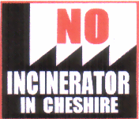
Representatives of CHAIN met George Osborne , MP for Tatton and Shadow Chancellor of the Exchequer in Barnton Memorial Hall, on 1 December. Two members of Cheshire West and Chester Council, Malcolm Byram and Norman Wright, were also present. The purpose of the meeting was to brief Mr Osborne on the background to the campaign against the Brunner Mond huge waste incinerator that could be located in his constituency. During the briefing he declared his ongoing support for the CHAIN campaign and promised his further assistance as and when necessary. Mr Osborne finished the meeting by being the first to sign the new CHAIN petition that has since been distributed throughout Northwich.

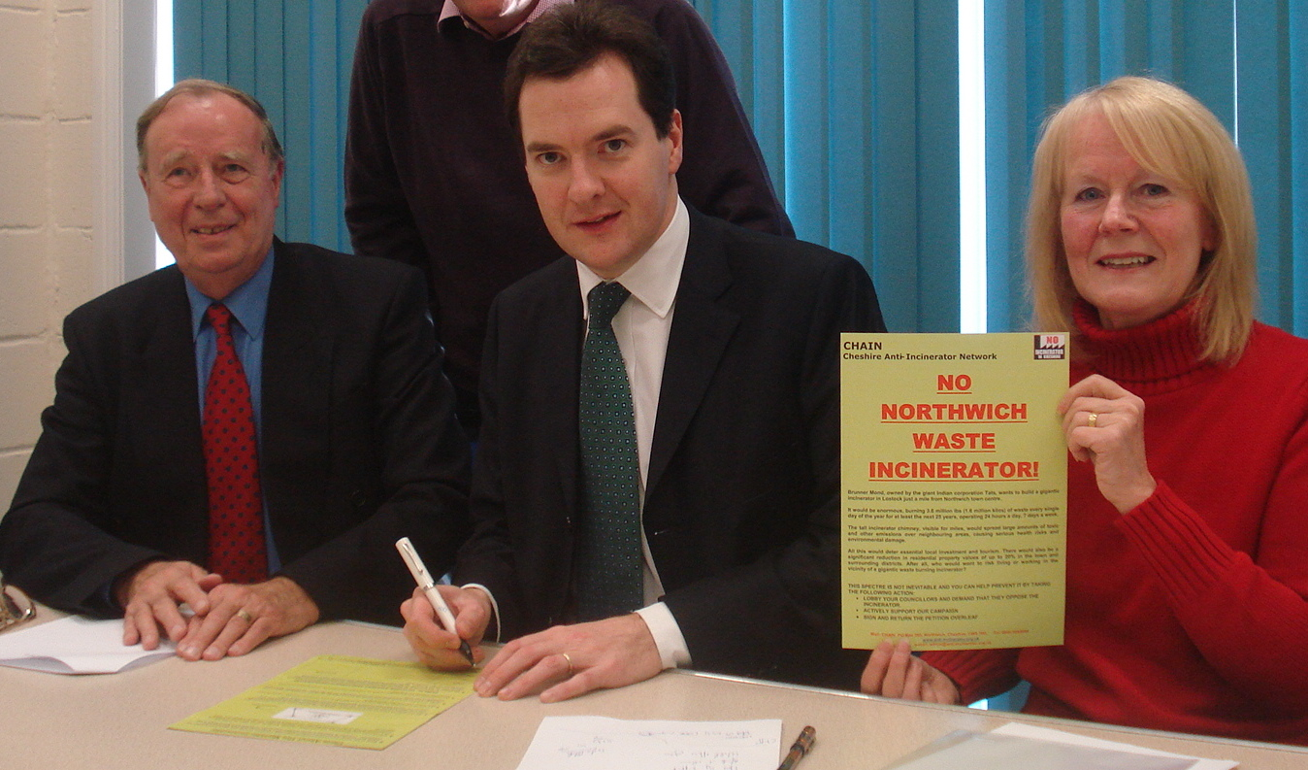

Brian Cartwright, Chairman of CHAIN, who was at the meeting, stated:
“I am sure that the thousands of people in Northwich who have been shocked by the Brunner Mond announcement will be grateful for George Osborne’s support. Many have been in touch with us, deeply worried about the serious health risks, the environmental damage, the inevitable traffic chaos and angered by the sheer effrontery of others sending waste to their home town for burning. In giving his support today and signing our petition, he has shown an understanding of their concerns. This is nothing to do with party politics. Our three local MPs have all objected to an incinerator in Northwich and I sincerely hope that other politicians in the area will soon follow their example”.

